Lab 7: Docker
docker :
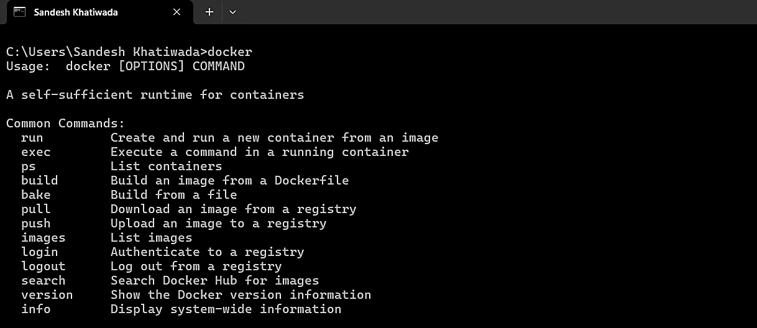

Pulling image using image (GUI version):
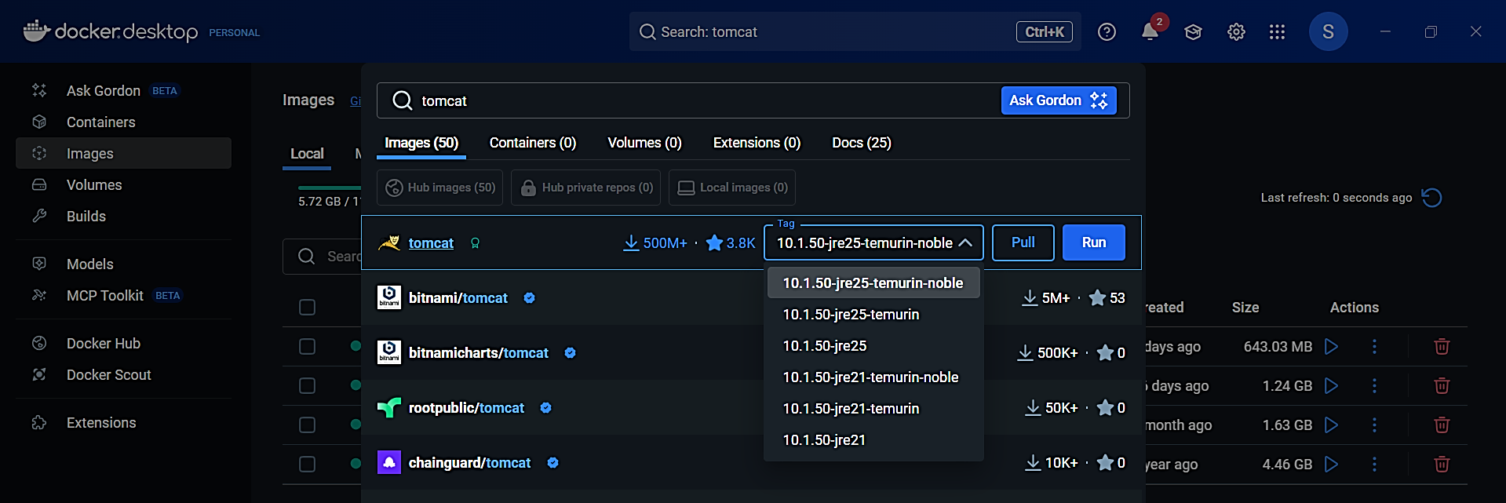

Pull docker image and run it :
docker pull tomcat:9.0-alpine
docker run -d --name tomcat_sandesh -p 8080:8080 tomcat:9.0-alpine
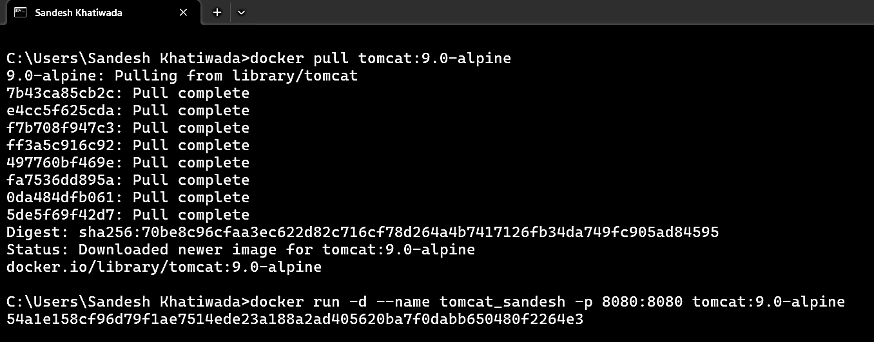

Check active docker in windows
docker ps
docker ps | findstr tomcat_sandesh
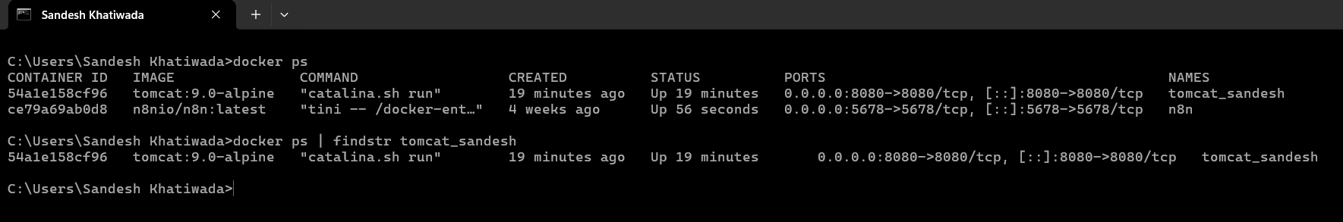
Docker logs via command:
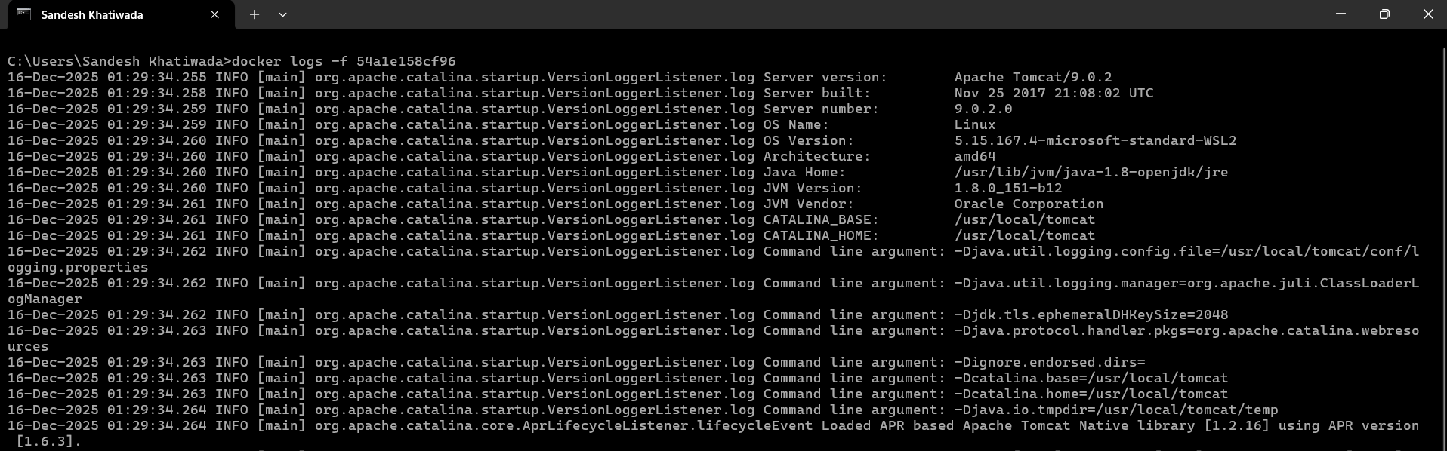
Docker logs via GUI:
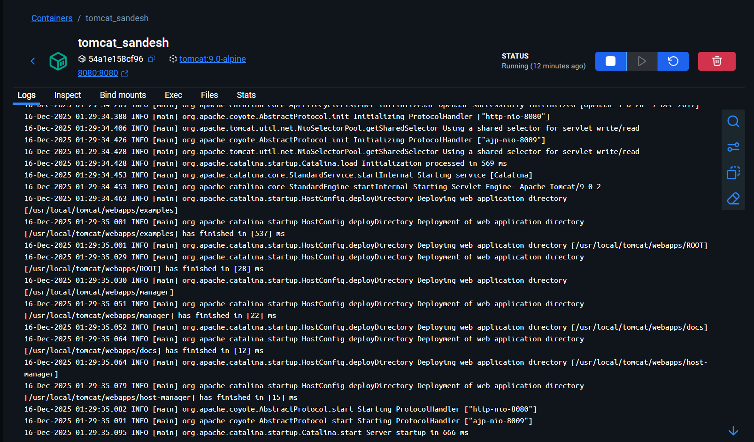

Docker inspect:
docker inspect tomcat_sandesh
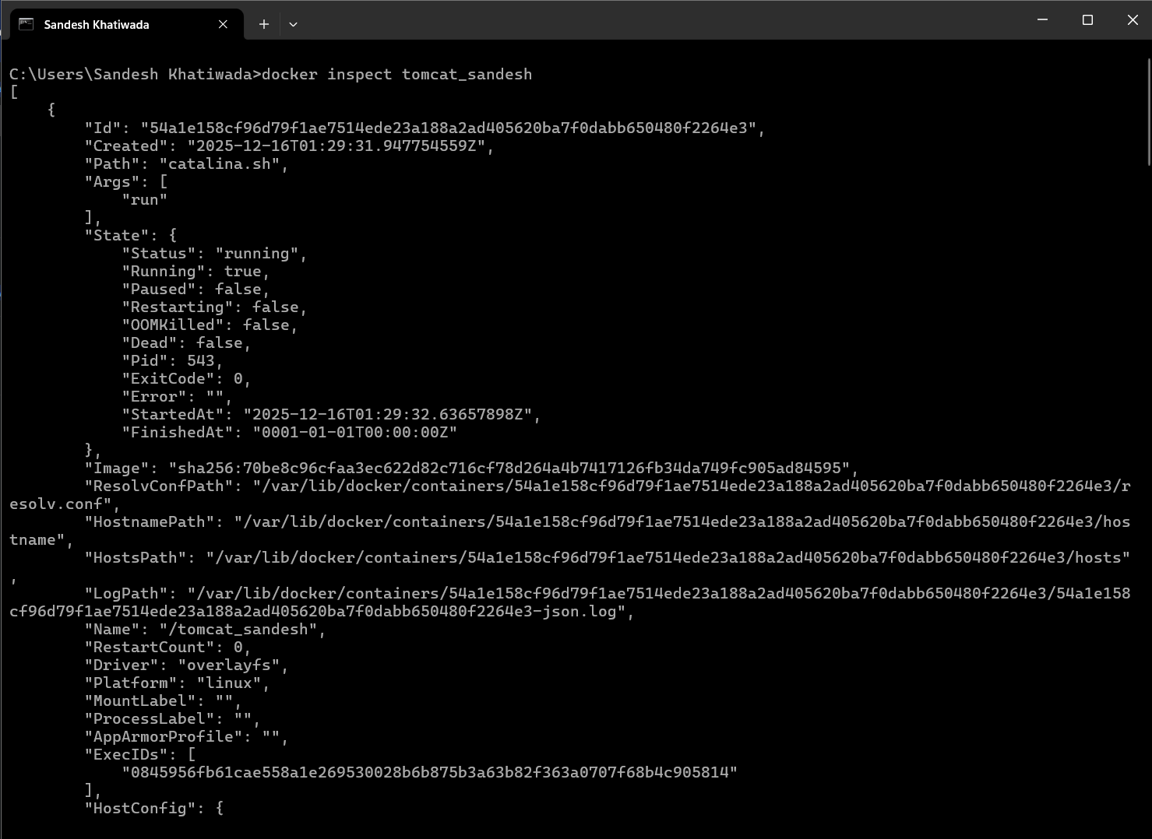
Inspection via Gui:
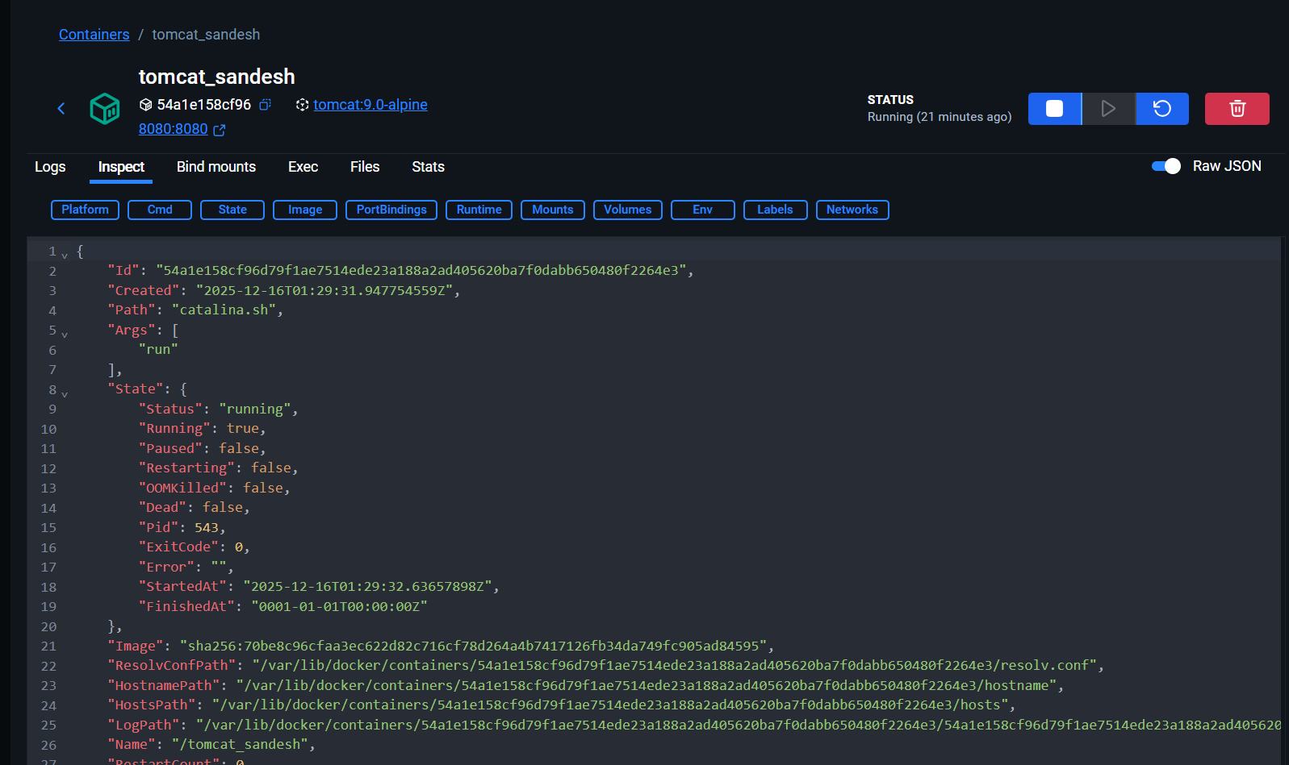

Checking localhost:8080
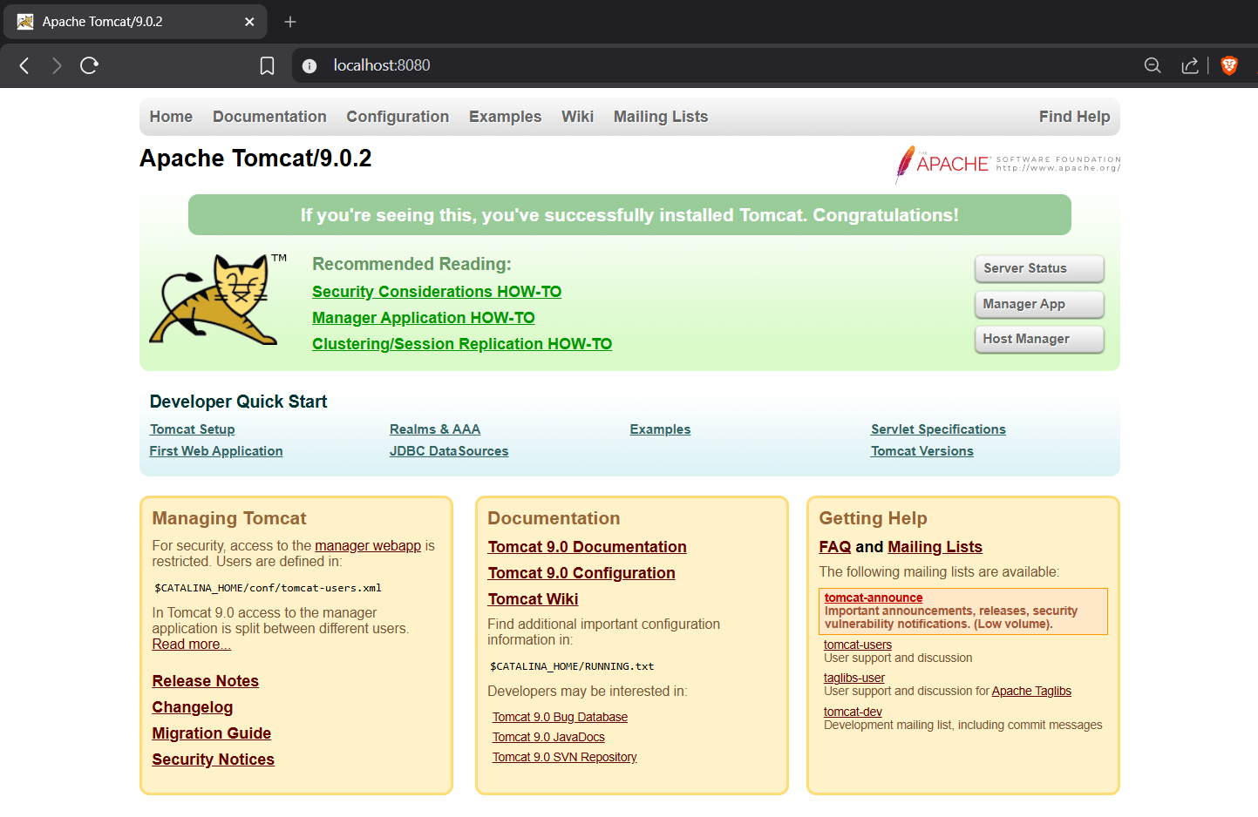
docker stop tomcat_sandesh
docker ps -a
docker start tomcat_sandesh
docker ps
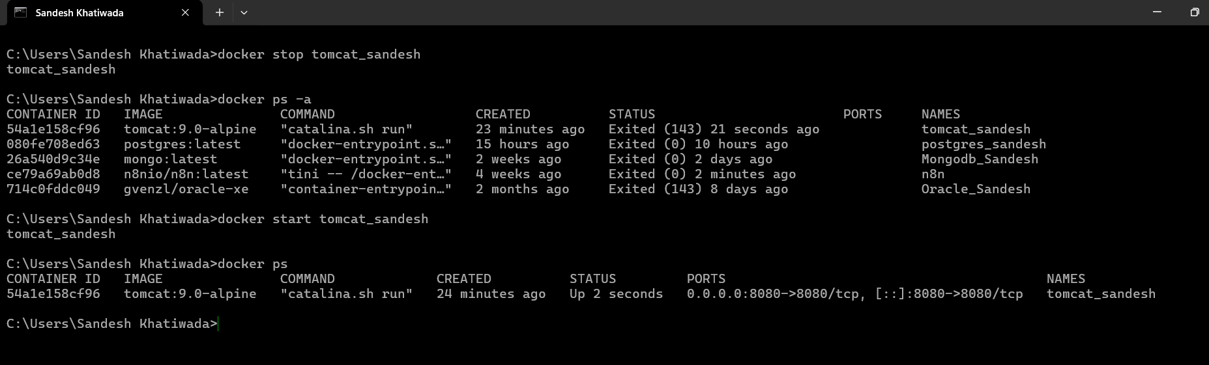
docker exec -it tomcat_sandesh sh
apk add wget
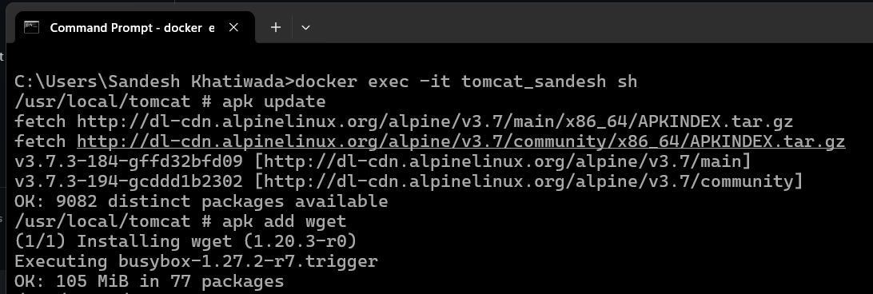
wget --version
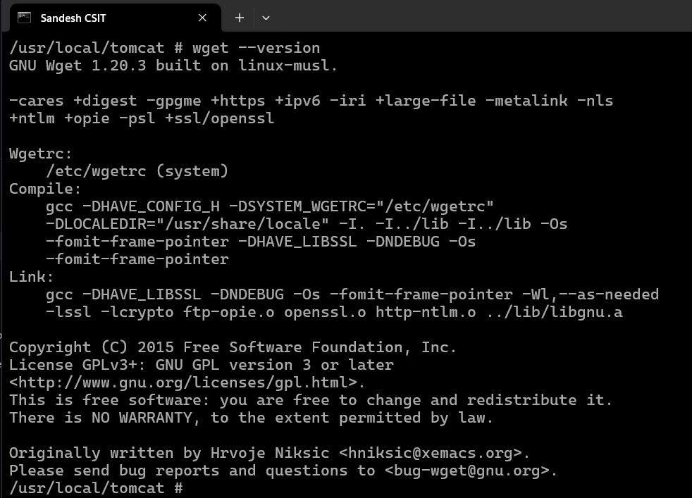
docker restart <conainerid>
